Views & functionalities of the pages of student Facial-attendance portal

*Login Page :*

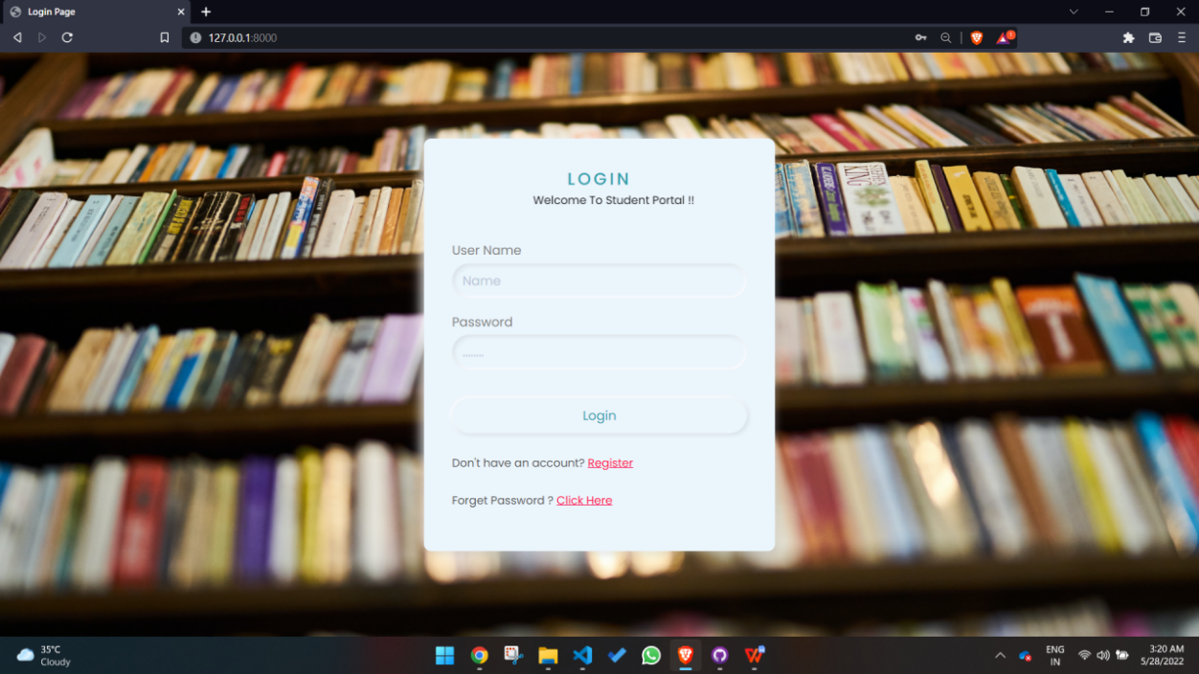

*Main Page after login :*

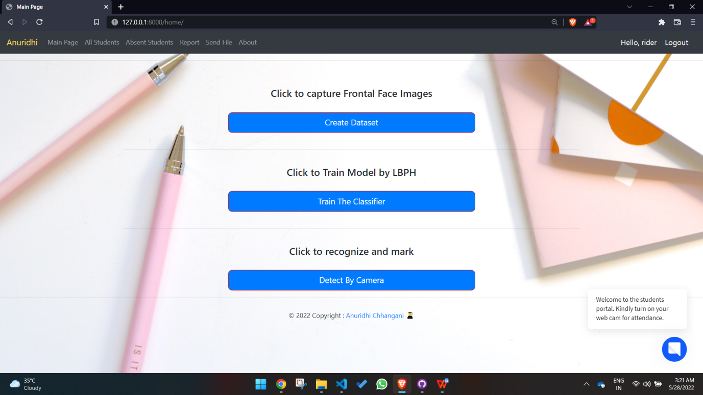

*On Clicking Create Dataset :*

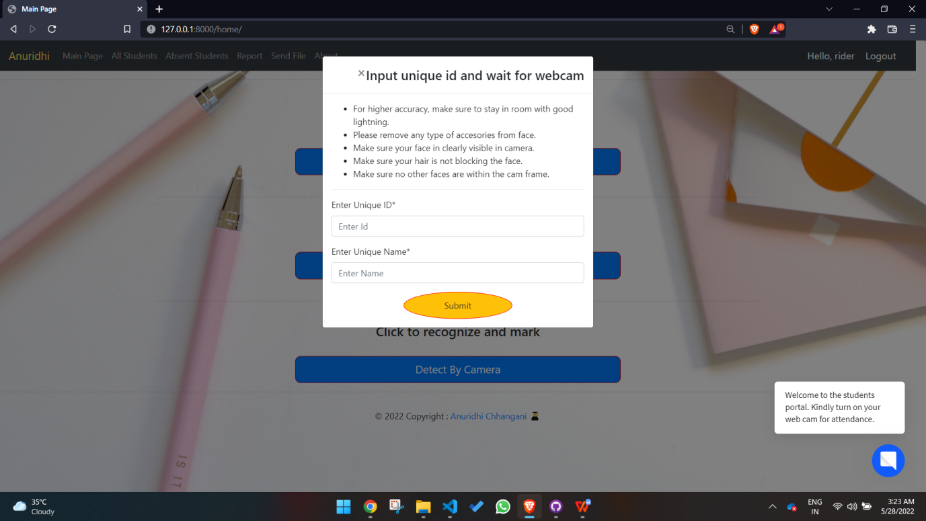

On Submitting a frame Opens & Captures 60 Images For Training :

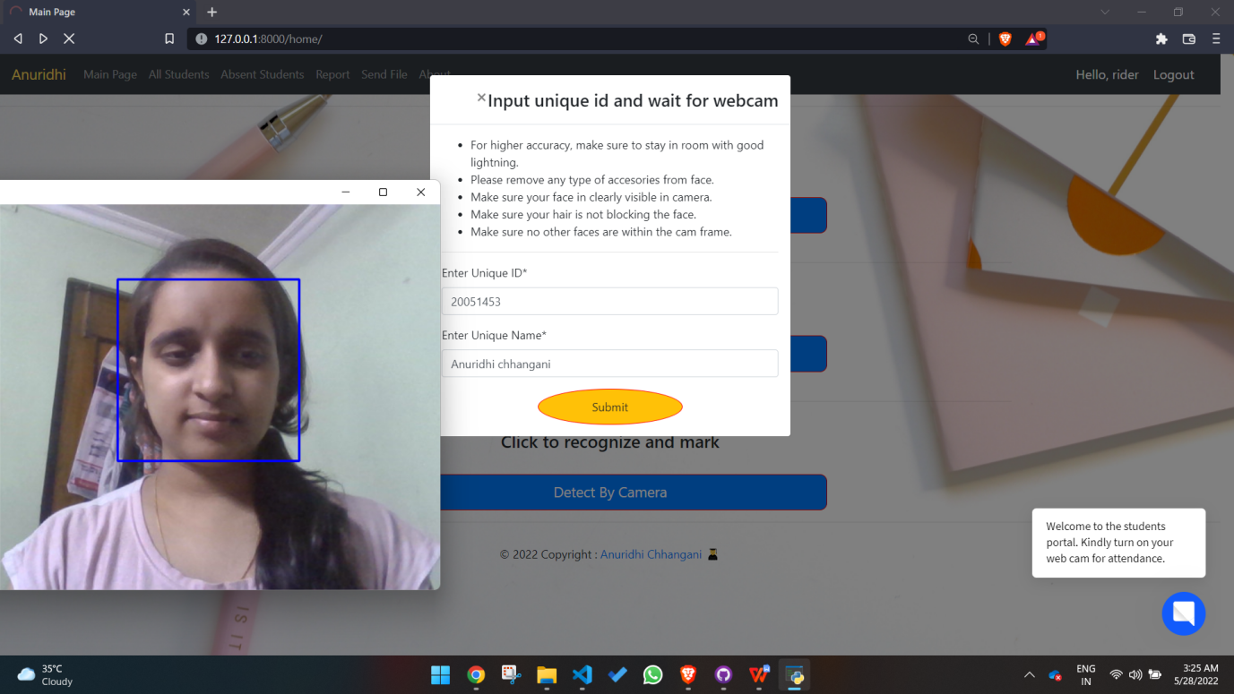

After Capturing Images & clicking On Train Classifier

A Frame will Show That The Images Are Training

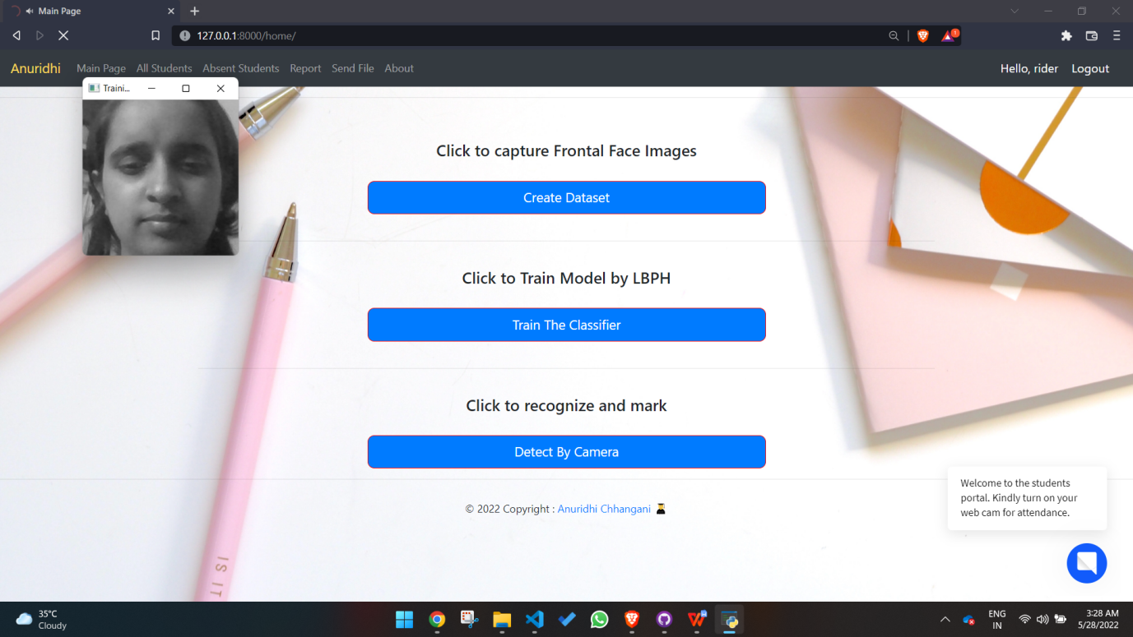

After Clicking Detect By Camera A Frame will Open And Take attendance and Show The Profile Of The Detected User :

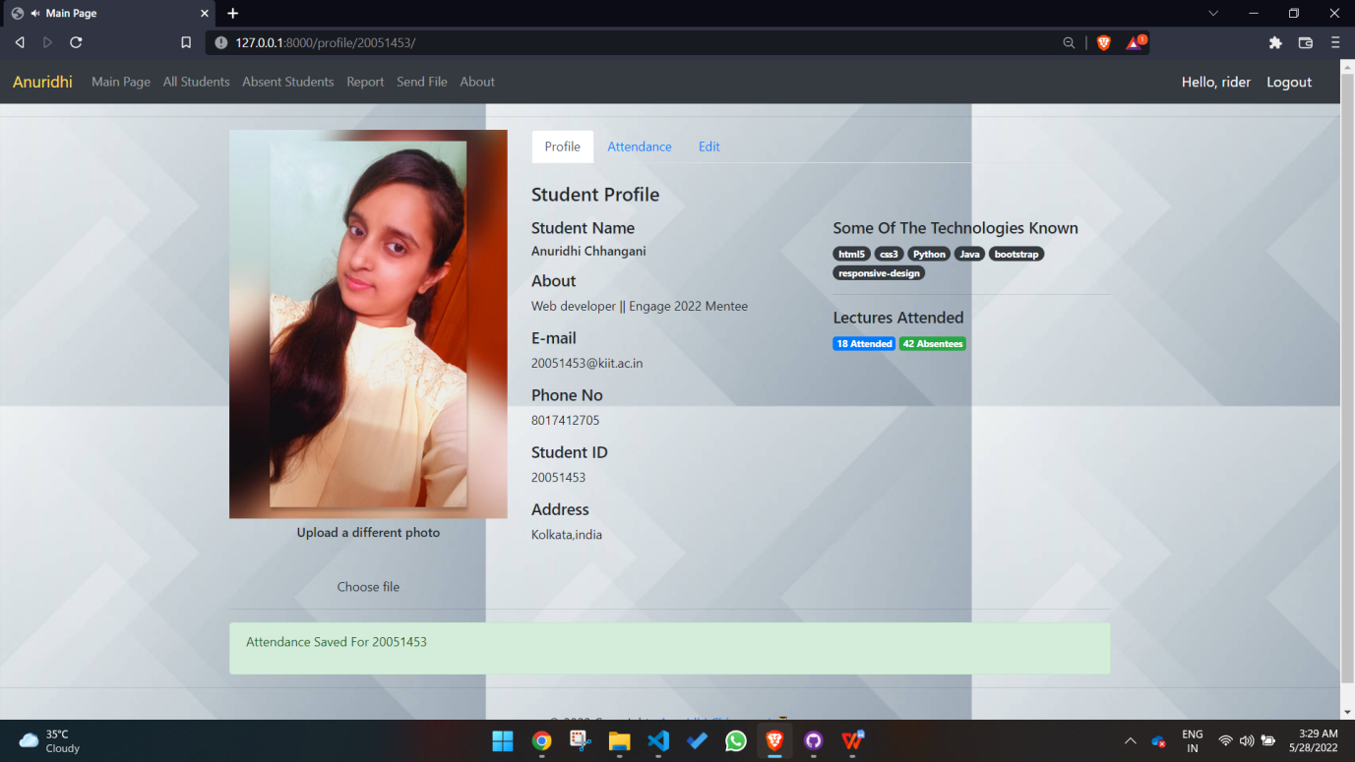

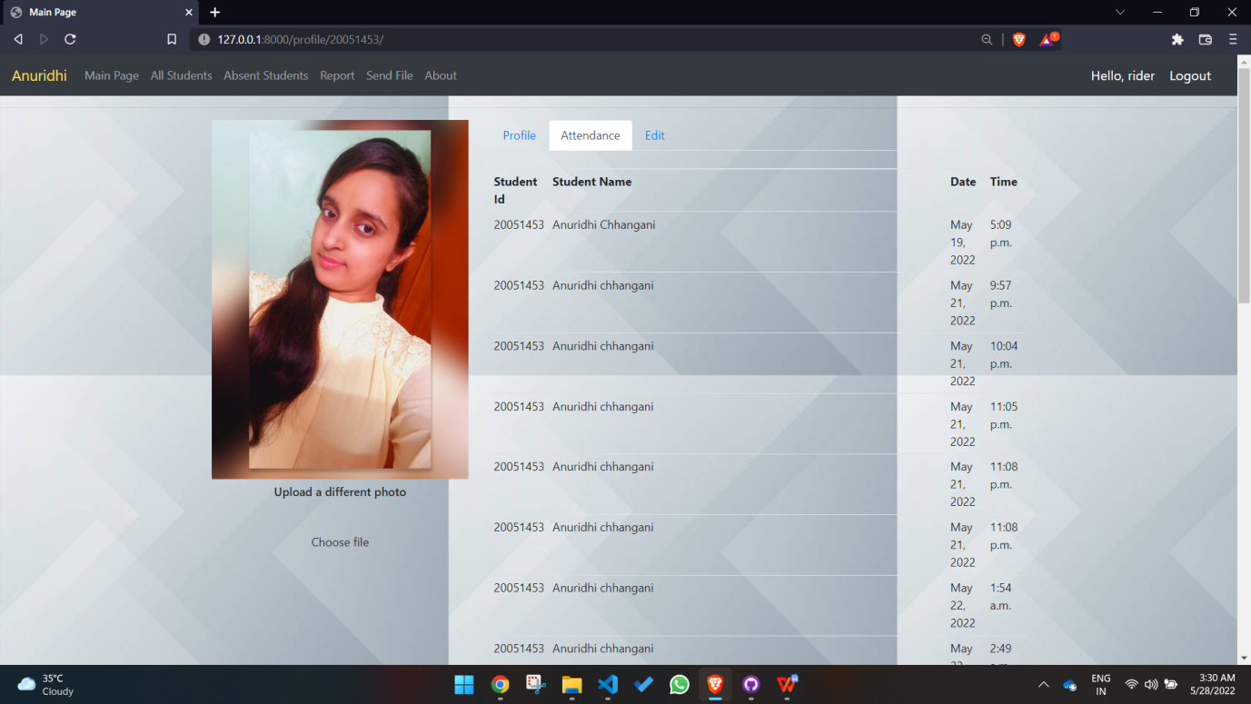

After Clicking on All Students We Can see All The Students With The Count :

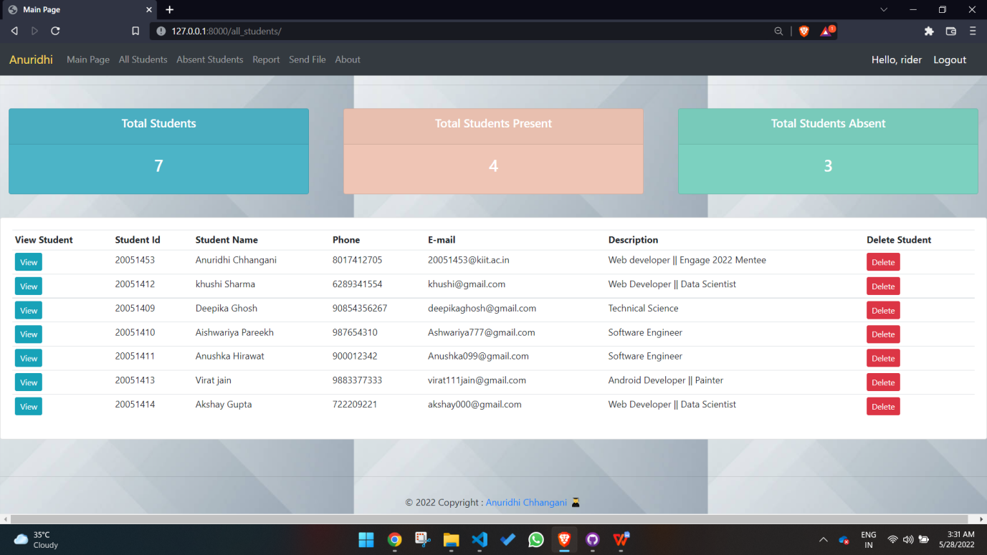

Now , on Clicking Absent It Shows All Those Students Who Were Absent :

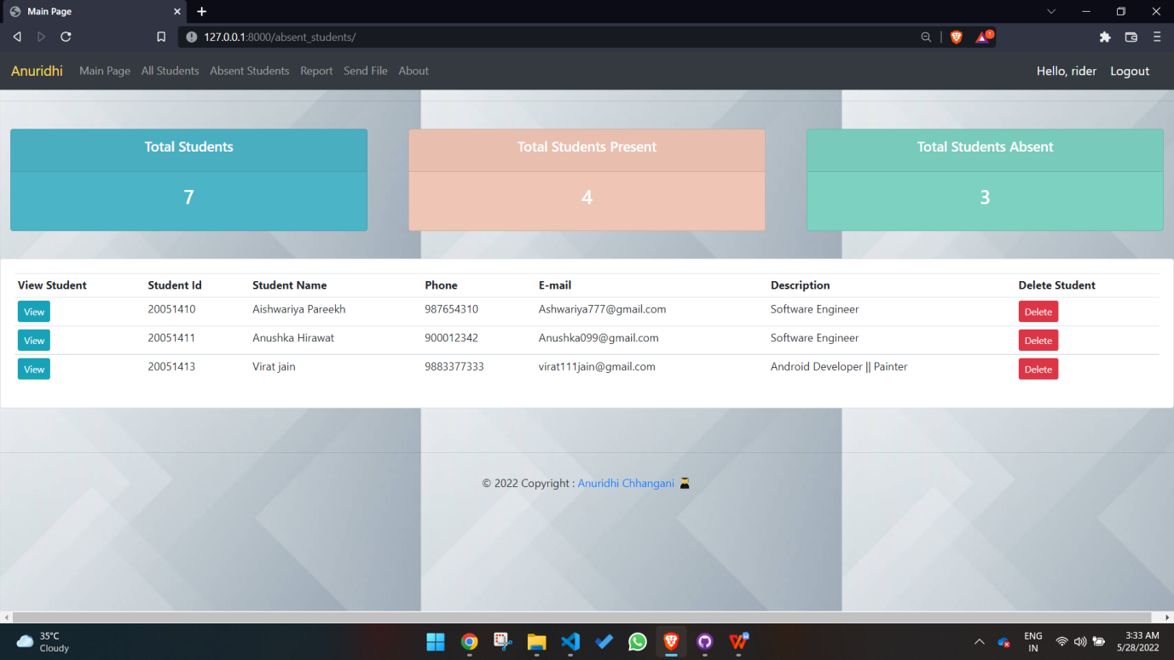

On Clicking The Report Tab It Creates A Real time Report On Students With Time Stamp :

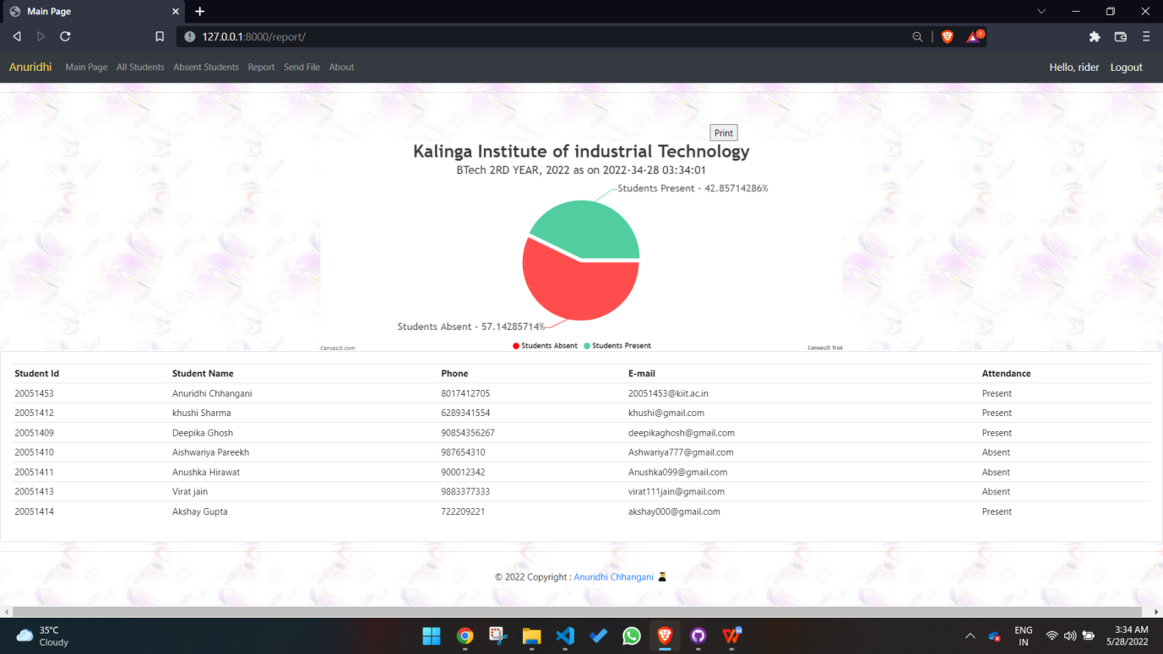

Printable Report PDF :

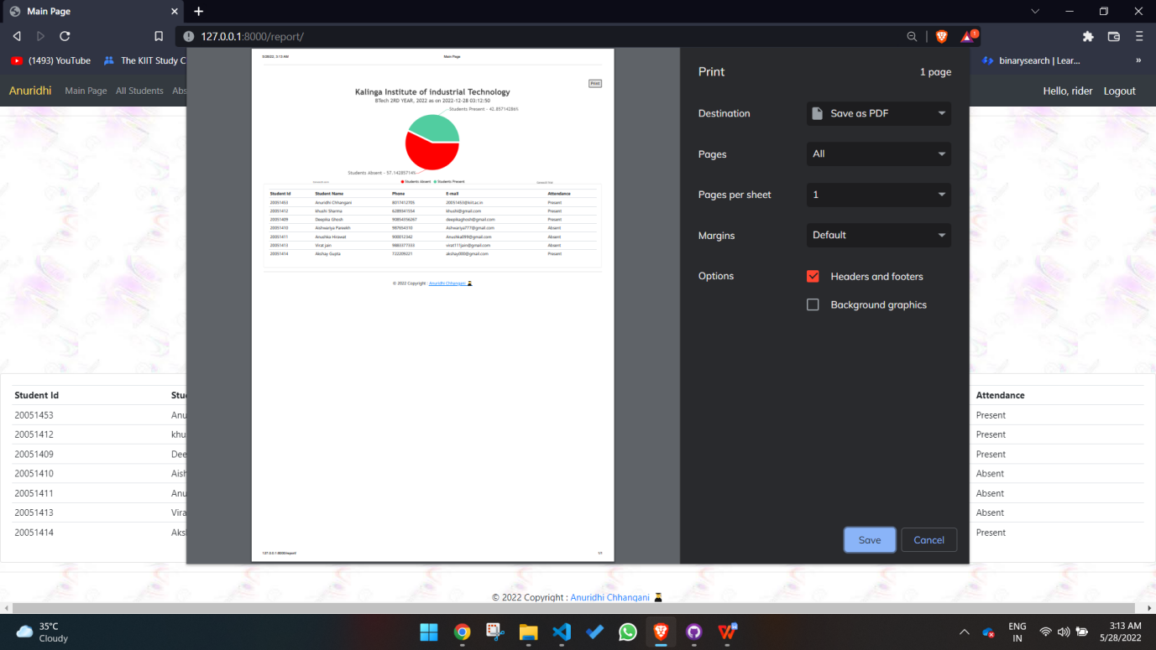

The send file page allows user to Send The Mail : 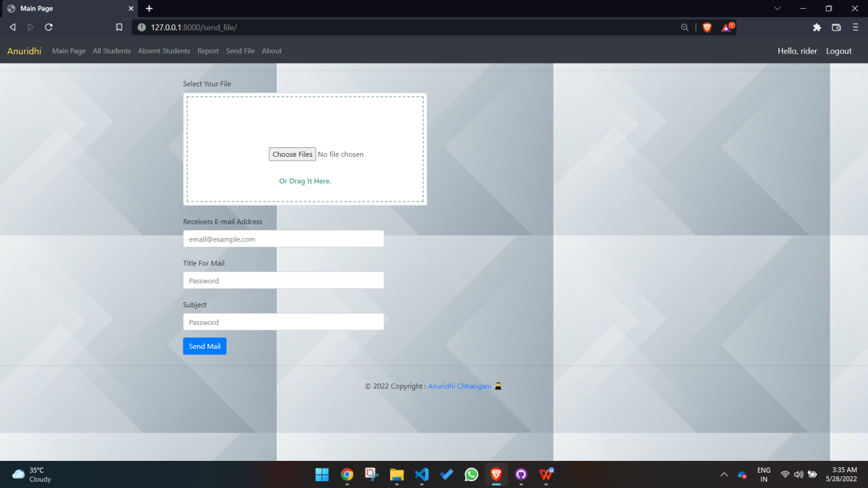

The About page for the project :

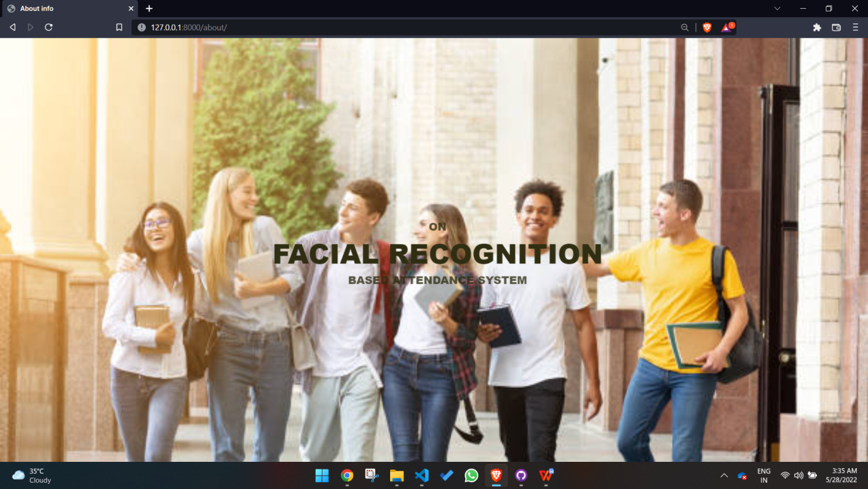

THANK YOU

--x--